University of California Berkley's Data Analytics course,

This repository is a basic analysis of hypotheses and questions inspired by the commodity data of global coffee prices. For this analysis, we utilized Excel, Python, Pandas, Matplotlib, and APIs.

Credits:

[JoeBrueneman](https://github.com/JoeBrueneman/Commodity_Trading_Analysis/commits?author=JoeBrueneman)

[Sophiatun](https://github.com/JoeBrueneman/Commodity_Trading_Analysis/commits?author=Sophiatun)

[sylHut](https://github.com/JoeBrueneman/Commodity_Trading_Analysis/commits?author=sylHut)

[Martinperezmh](https://github.com/martinperezmh)

Immanuel User Name

**Coffee** is a highly traded good internationally among many countries. It is also a heavily imported good for the U.S.

But what affects the price?

Questions

* Coffee *vs.* **Stock** **Market**

What are the stock prices of major players vs coffee prices and do they correlate?

* Coffee *vs*. **Global Economy**

Is GDP of major coffee-producing countries influenced by the price of coffee globally?

* Coffee *vs*. **Pandemic**

Did unemployment during the pandemic increase the consumption/price of coffee?

* Coffee *vs*. **Commodity**

Does the price of Oil (West Texas Intermediate) or Natural Gas impact the price of imported coffee from major players?

Hypothesis

There will be a significantly positive relationship in the price fluctuations between fuel (oil/natural gas) and coffee.

**Null** Hypothesis

Due to the labor-intensive nature of the coffee production industry, global coffee prices will be primarily driven by other factors, such as labor costs, rather than the fuel prices that affect freight costs.

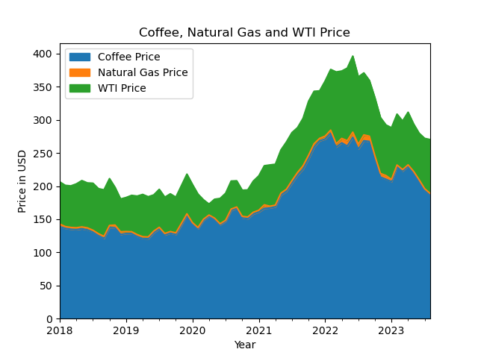

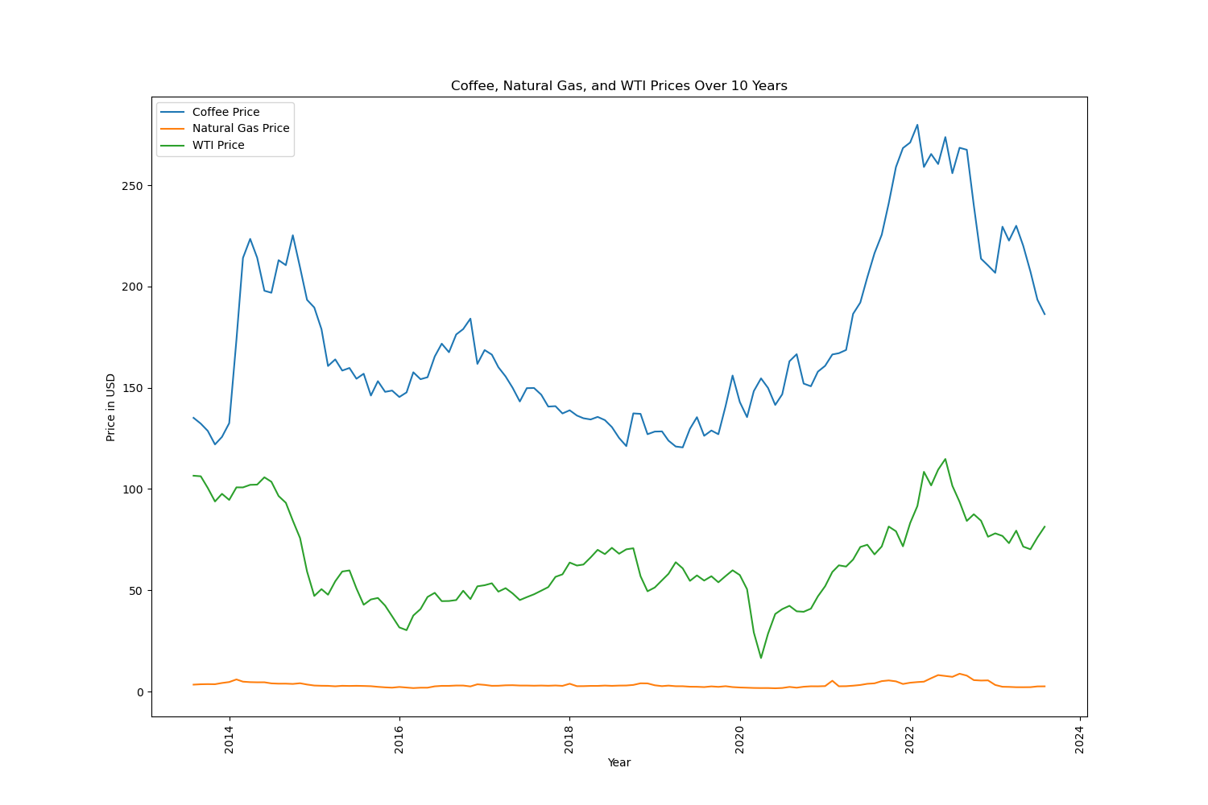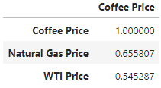

Hypothesis

The coffee price changes will drive fluctuations of those countries’ GDPs.

**Null** Hypothesis was

There will not be a correlation between the major coffee producing countries’ GDPs and the coffee prices.

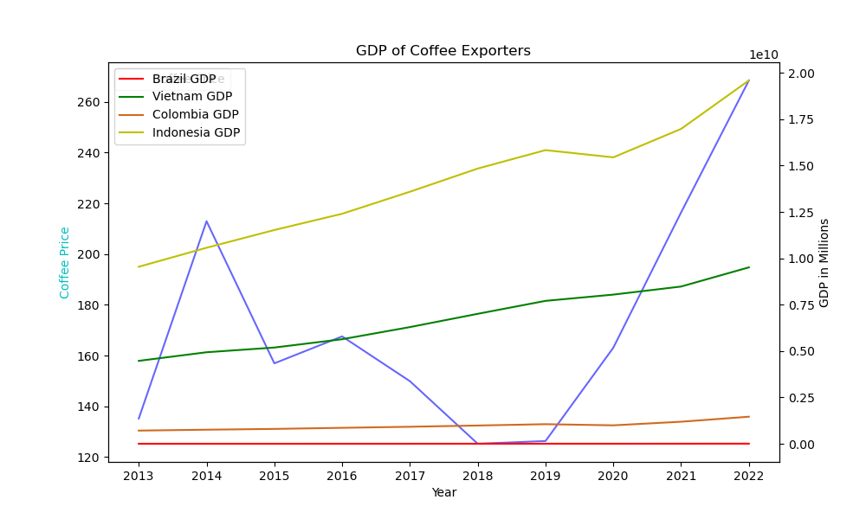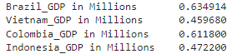

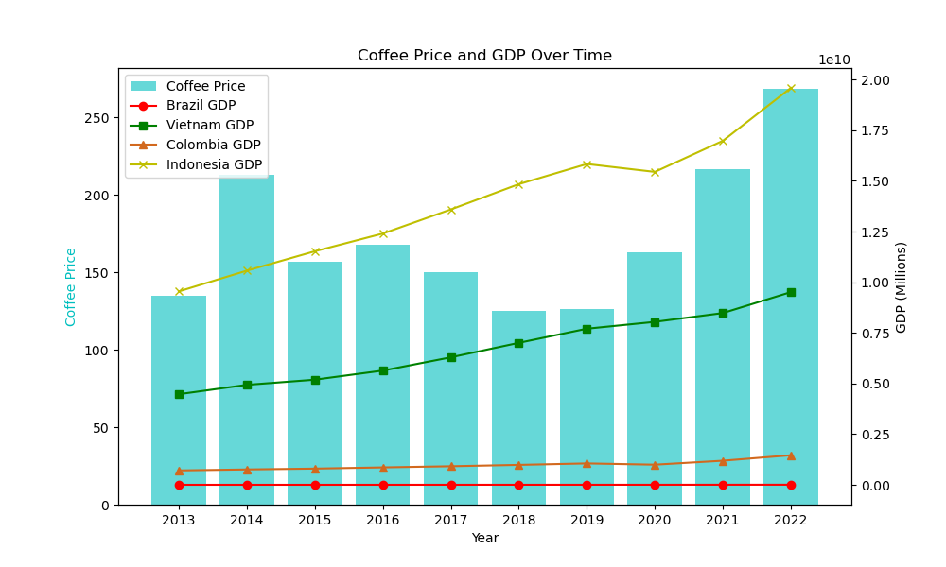

Hypothesis

The global coffee price increases will negatively impact the stock prices of major coffee companies.

**Null** Hypothesis

Since the raw coffee price is not the only cost associated with the coffee companies’ performances in the stock market, there will be no correlation between the global coffee price and the major coffee companies’ stock prices.

lol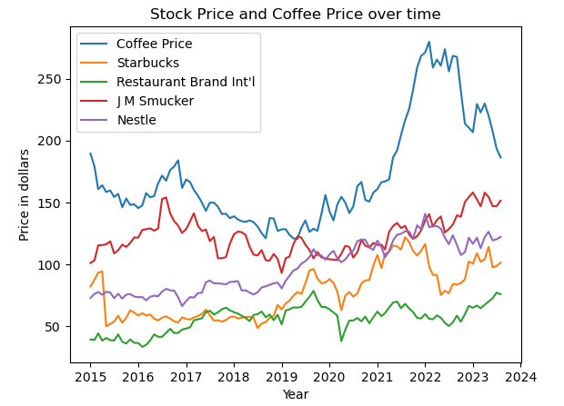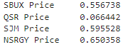

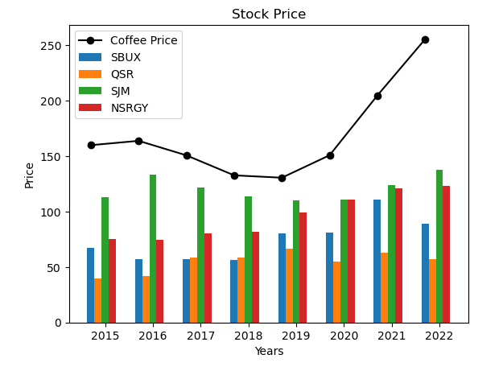

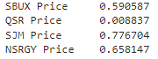

Hypothesis

There will be an inverse relationship between unemployment during the COVID-19 pandemic and coffee prices.

**Null** Hypothesis

A slowdown in the labor market during the pandemic will not impact coffee prices because coffee is a major staple in people’s daily life.

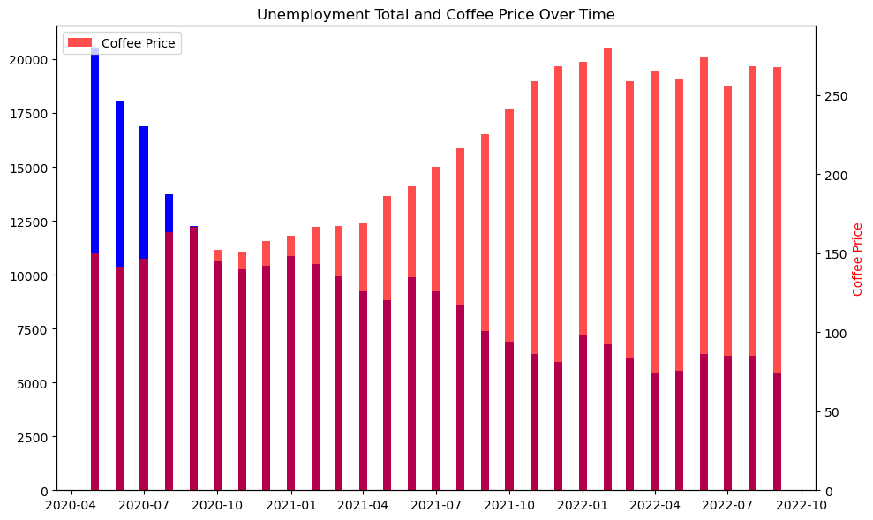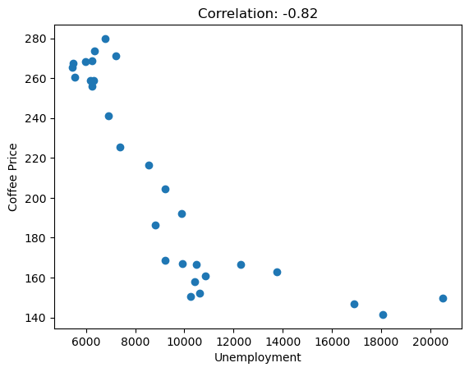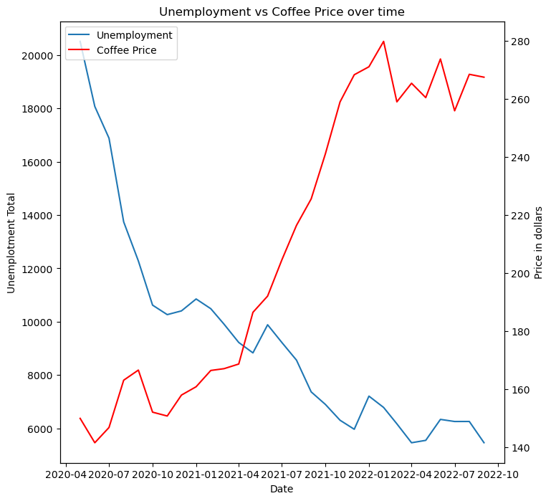

Conclusion

* Coffee *vs.* **Stock** **Market**

**➽ Very Weak to Strong Correlations**

* Coffee *vs*. **Global Economy**

**➽ Very Weak to Moderate Correlations**

* Coffee *vs*. **Pandemic**

**➽ Very Strong Negative Correlation**

* Coffee *vs*. **Commodity**

**➽ Moderate Correlations**